Spring Cloud Config Demo Using GIT Repo

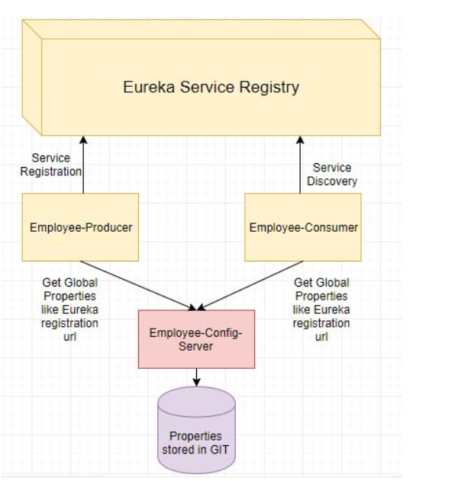

The steps we will be following

* Creating a Git Project. Creating the application.properties in this project
* Modifying the employee-config-server module we created previously to use the application.properties from the Git Repo instead of Native files.

Configure the Git Repo

1. Got to [GitHib](https://github.com/). If already have an account login or else SignUp
2. Create a new repository named employee-config-server.

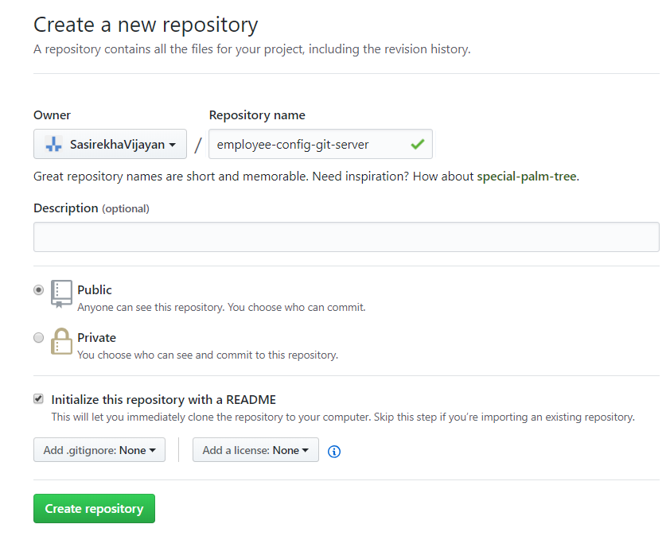

1. Create the repository by clicking the create repository button.

Then create a new file named application.properties, copy the global properties like Eureka url and commit this file.

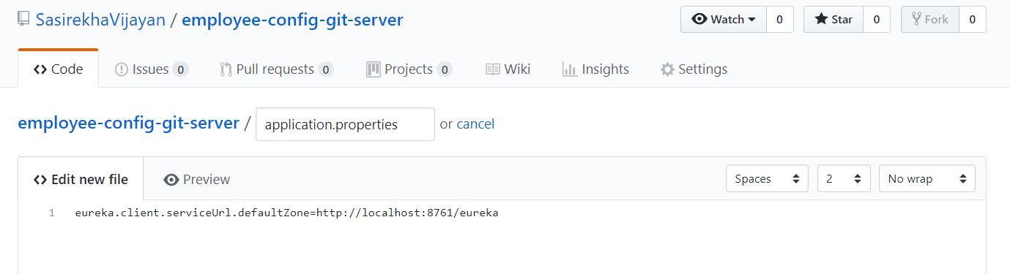

eureka.client.serviceUrl.defaultZone=http://localhost:8761/eureka

Commit the file.

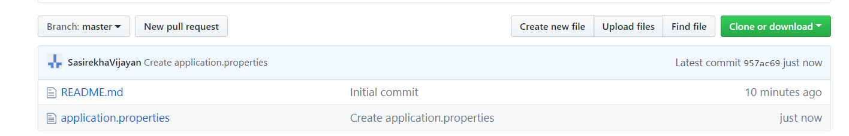

Next we will modify the [config-server module](https://www.javainuse.com/spring/spring_cloud_config_server)

From the src/main/resources/application.properties remove the native property and add the Git project url we just created as follows-

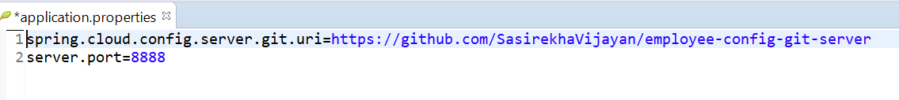

2. We can now delete the common-config folders as the global properties will be read from Git Repo.

Next start the modules in following sequence-

* employee-config-server
* eureka-server
* employee-producer

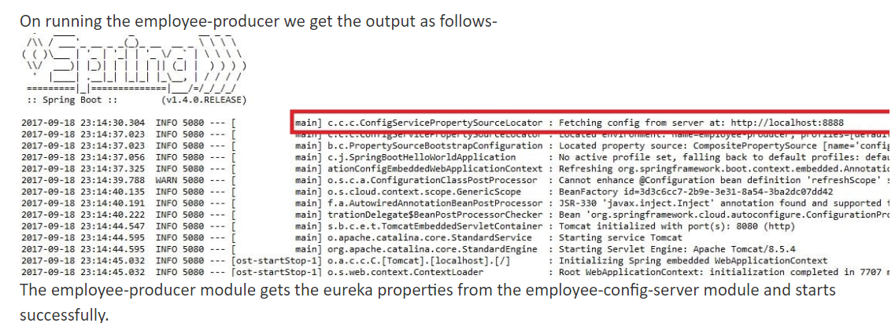

@@@@@@@@@@@@@@@@@@> Happy Learning <@@@@@@@@@@@@@@@@@@@

Source Code

